Experiment 4
OLAP Operations Experiment

Aim
OLAP Operations (Slice, Dice, Drill-up & Drill-down) using Microsoft
Power BI

Tools / Software Required
1. Microsoft Power BI Desktop
2. Global Superstore Dataset.xlsx
3. Power Query Editor (Built into Power BI Desktop)
4. DAX (Data Analysis Expressions)
Dataset Source:
Global Superstore Dataset (Kaggle)
https://www.kaggle.com/datasets/apoorvaappz/global-super-store-dataset

Theory
OLAP (Online Analytical Processing) is a technology used to analyze large amounts of data from multiple dimensions. It allows users to examine data from different perspectives and at different levels of detail.
For example, in a Sales dataset, we may have:
- Time: Year → Quarter → Month
- Geography: Country → State → City
- Product: Category → Subcategory → Product
- Measures: Sales, Quantity, Profit
Power BI provides interactive visualizations and filtering capabilities that can be used to perform OLAP-style analysis.

1. Slice
Slice selects a single value from one dimension and analyzes the resulting subset of data.
Example:
Suppose the dataset contains sales for 2024 and 2025. Selecting only 2025 creates a slice of the sales data.
In Power BI:
- Import the sales dataset.
- Create a chart showing Sales by Region.
- Add a Year slicer.
- Select 2025.
- The visual now displays sales only for 2025.
Result: Data is filtered based on one dimension.

2. Dice
Dice selects multiple values from multiple dimensions to create a smaller subset of the data.
Example:
Analyze:
- Years: 2024 and 2025
- Regions: North and South
- Categories: Electronics and Furniture
This produces a smaller multidimensional subset.
In Power BI:
- Add a Year slicer.
- Add a Region slicer.
- Add a Product Category slicer.
- Select the required values from each slicer.
- The report displays only the selected combination.
Result: Data is filtered simultaneously using multiple dimensions.

3. Drill-down
Drill-down moves from a higher-level summary to more detailed information.
For example:
Year → Quarter → Month → Day
Suppose a chart displays:
2025 → Q1 → January → Day
Clicking the Drill Down button allows you to move from yearly sales to quarterly, monthly, and daily sales.
In Power BI:
- Create a hierarchy such as:
Year > Quarter > Month.
- Add the hierarchy to a chart's axis.
- Enable the Drill Down option.
- Select a year.
- Power BI displays the corresponding quarters.
- Continue drilling down to months.
Result: More detailed information is obtained from summarized data.

4. Drill-up
Drill-up is the reverse of drill-down. It moves from detailed information to a higher-level summary.
For example:
Day → Month → Quarter → Year
If the report currently shows monthly sales, drilling up can return to quarterly or yearly sales.
Result: Detailed information is summarized into a higher-level view.

Conduct
Part A: Load DataModel
Step 1: Download the Global Superstore Dataset from Kaggle.
Step 2: Open Power BI Desktop.
Home > Get Data > Excel Workbook
Select Global Superstore Dataset.xlsx
Click Transform Data.
Step 3: Import the following worksheets:
• Orders
• Returns
• People
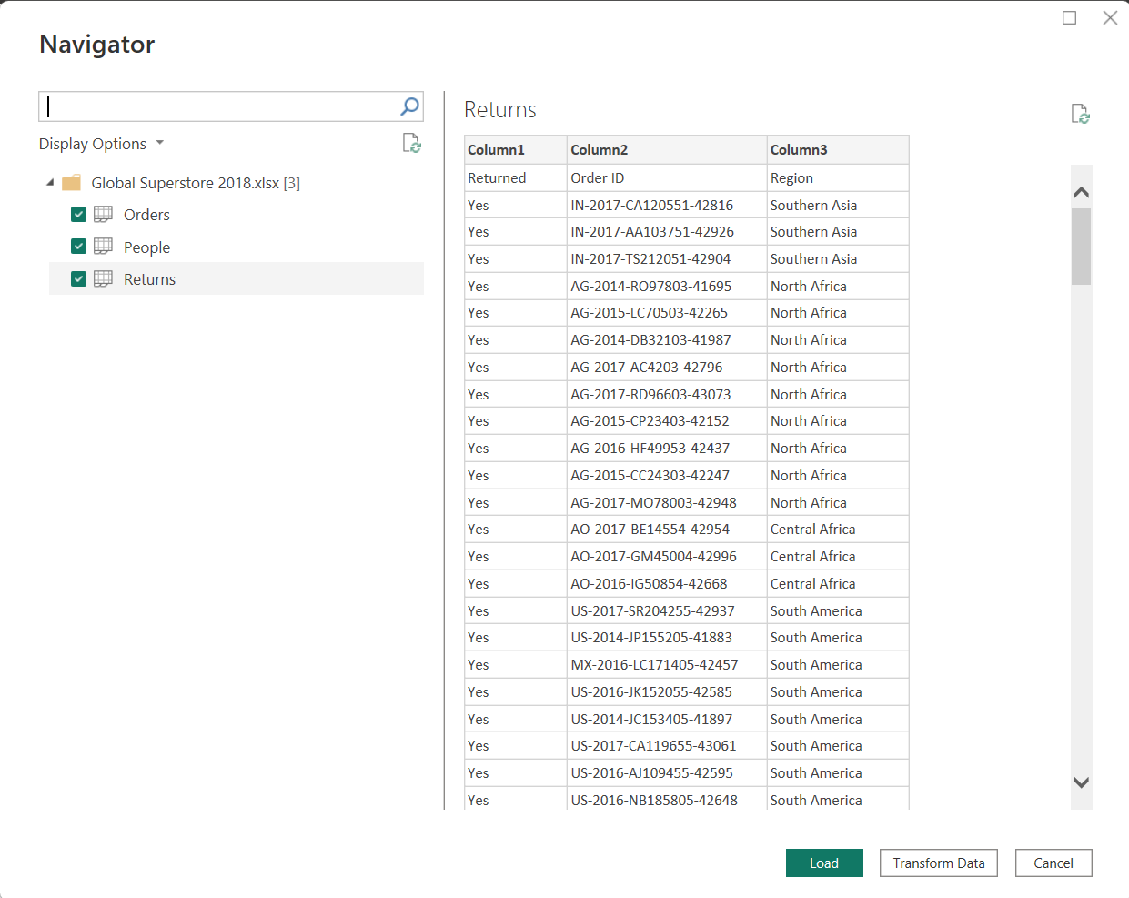
Verify that all imported tables appear in the Queries pane.

Part B: Verify Relationships
Step 4: Navigate to Model View.
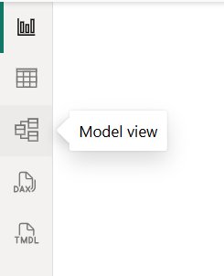
Step 5: Create relationships:
Orders ↔ Returns (Order ID)
Orders ↔ People (Region)
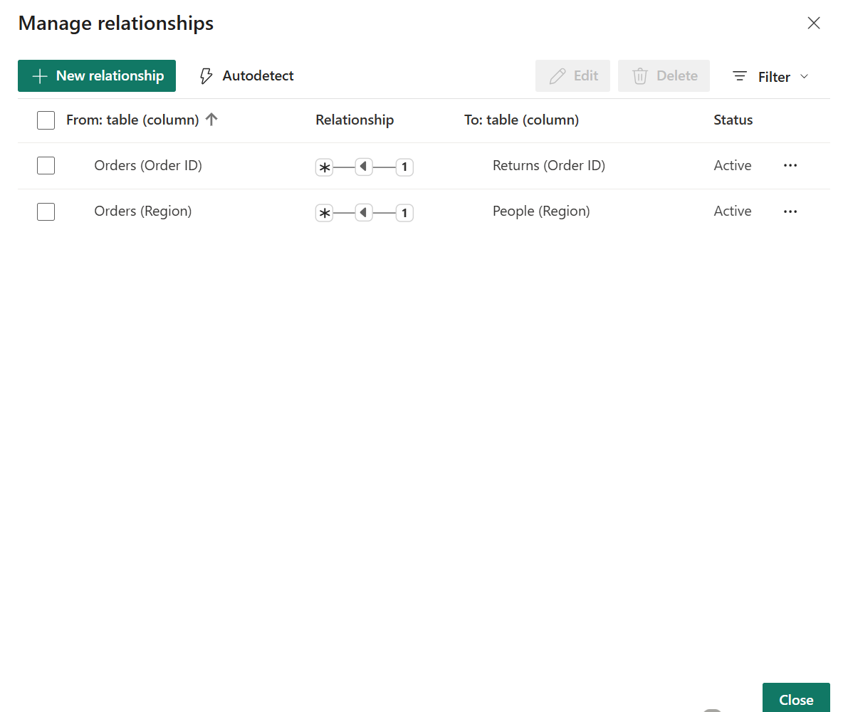

Part C: Foundational Analytical Canvas
Step 6: Establishing primary visualizations as the baseline for interactive OLAP operations
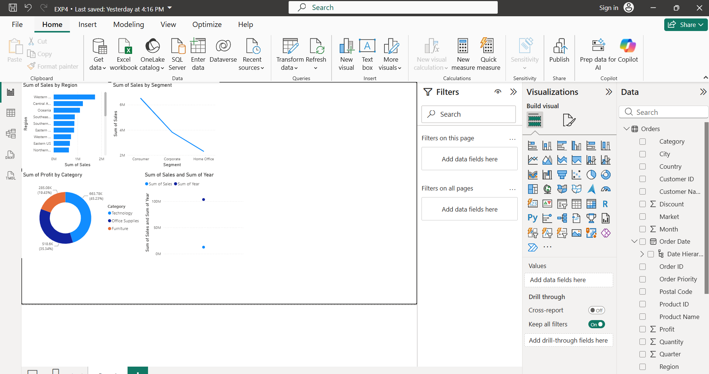
Step 7:Executing a Slice Operation
First, add a Slicer visual to your
report canvas.

Next, drag the 'Region' field into this
slicer.

And select the 'West' option.

Finally, observe the dynamic
changes across your Sales, Profit,
and Orders visuals.
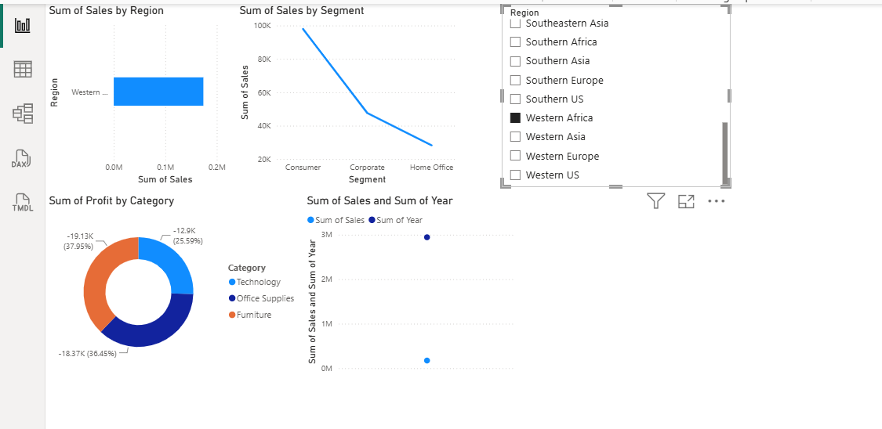
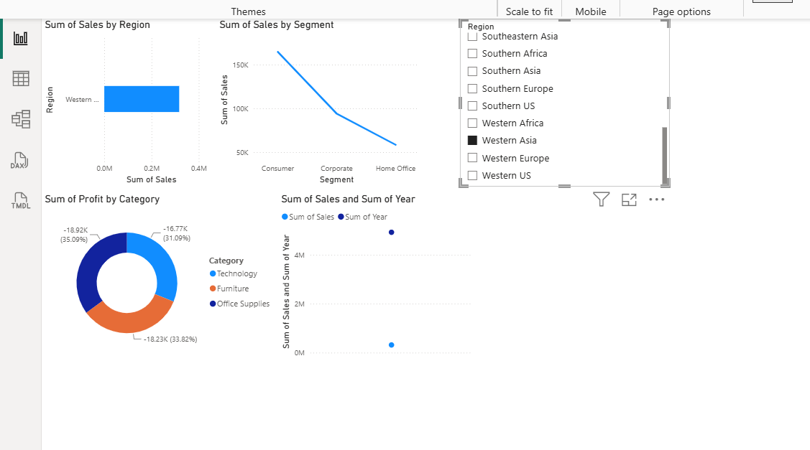
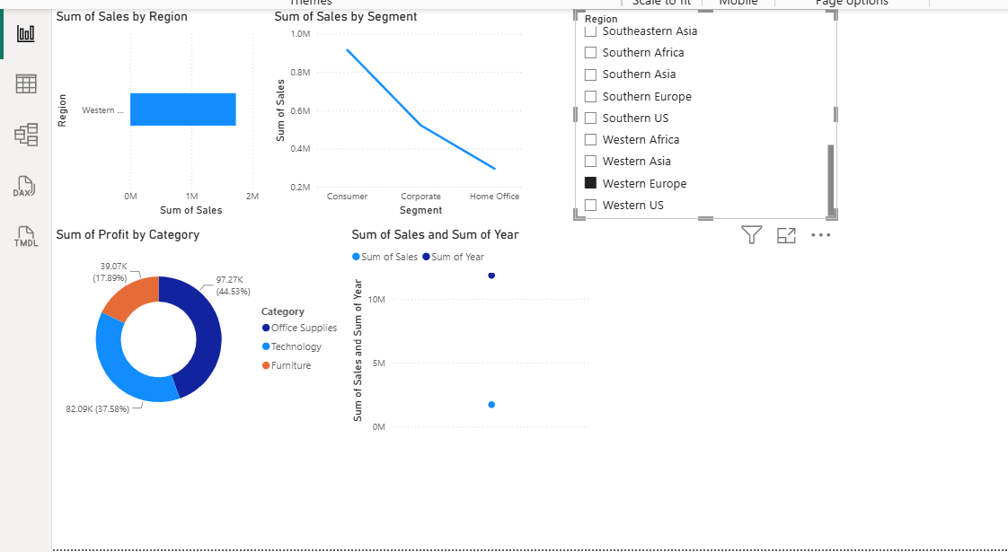
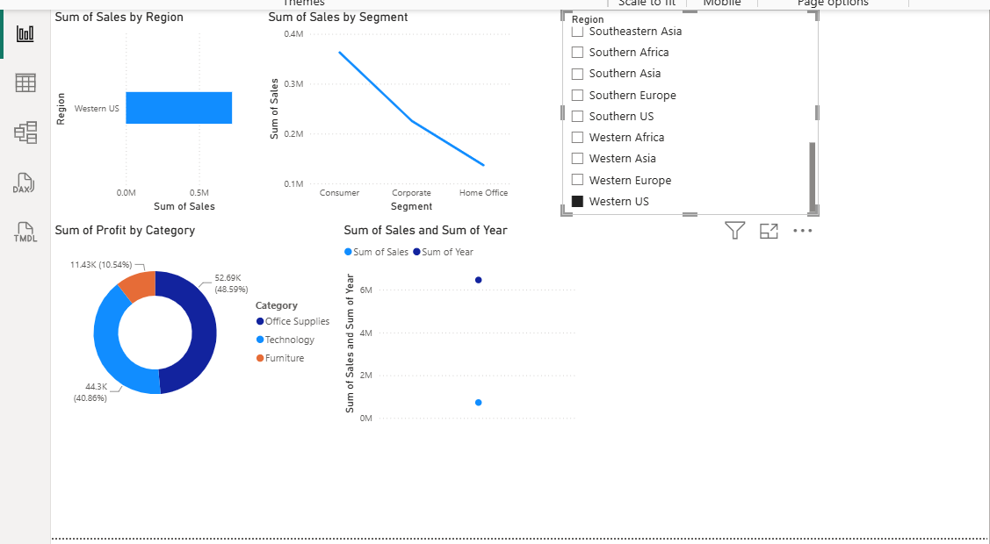
Step 8: Executing a Dice Operation
Isolating precise data sub-cubes across multiple dimensions simultaneously
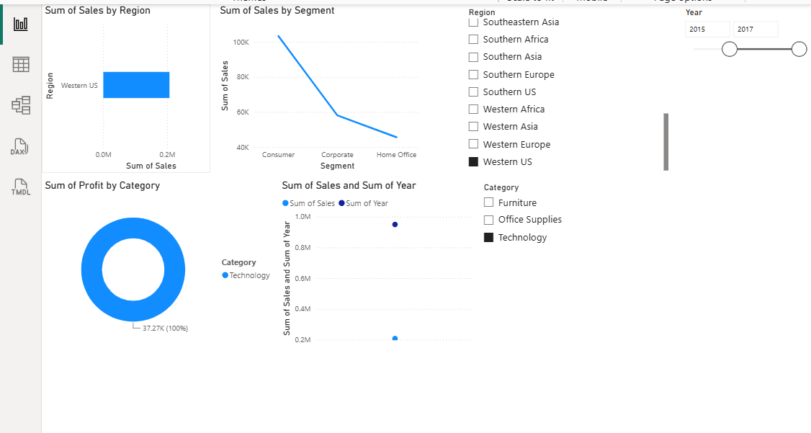
Step 9: Executing Drill-Down Operations
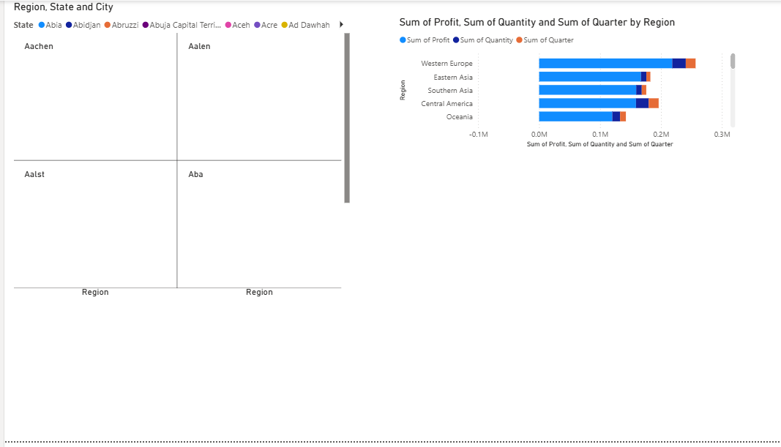

Step 10: Executing Drill-Up Operations

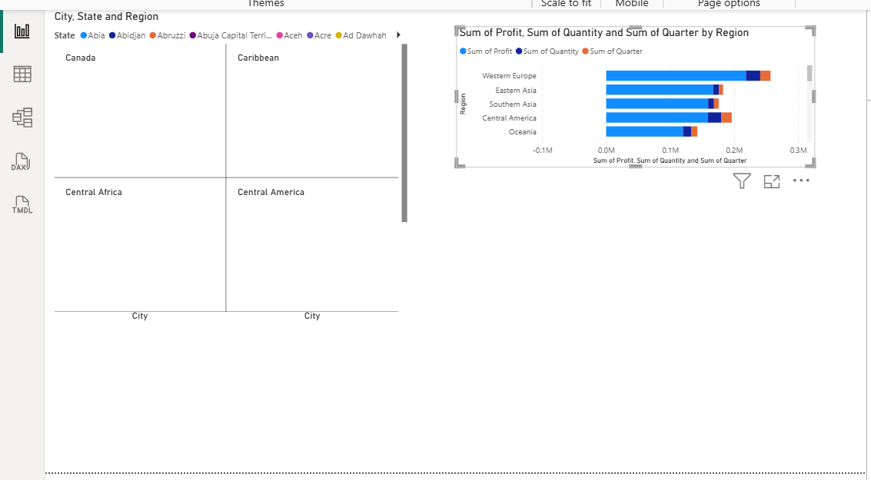

Result
The OLAP operations—Slice, Dice, Drill-down, and Drill-up—were successfully implemented using Microsoft Power BI. Interactive visualizations, slicers, filters, and hierarchies were used to analyze the sales data at different levels of detail. The operations enabled effective multidimensional analysis and helped in understanding trends and relationships within the dataset.

Learning Outcomes
After completing this experiment, students will be able to:
- Load and validate a BI model.
- Create analytical reports, and execute Slice and Dice operations.
- Creating hierarchies and performing Drill-down and Drill-up manoeuvres to compare multidimensional insights.

